TYITB145 Prathamesh Patil

Intent:
Prototype is a creational design pattern that lets you copy existing objects without making your code dependent on their classes.

Motivation:
To skip the object instantiation process and simplify the same process. By storing similar type of objects in an object registry.

Code:
// Author : Prathamesh Patil
import java.util.HashMap;

abstract class Color implements Cloneable{
abstract void addColor();
protected String color;

@Override
public Object clone(){
Object clone = null;
try{
clone = super.clone();
}
catch(CloneNotSupportedException exp){
System.out.println(exp.getMessage());
}
return clone;
}
}

class BlueColor extends Color{

public void addColor(){
System.out.println("Added Blue Color");
}

public BlueColor(){
this.color = "blue";
}
}

class BlackColor extends Color{

public void addColor(){
System.out.println("Added Black Color");
}

public BlackColor(){
this.color = "black";
}
}

class ColorStore{
static HashMap<String, Color> mp = new HashMap<String, Color>();

static{
mp.put("blue", new BlueColor());
mp.put("black", new BlackColor());
}

static Color getColor(String col){
return (Color) mp.get(col).clone();
}

}

class ColorTest {
public static void main(String[] args) {
System.out.println(ColorStore.getColor("blue"));
System.out.println(ColorStore.getColor("blue"));
System.out.println(ColorStore.getColor("black"));
System.out.println(ColorStore.getColor("black"));

}
}

Output:
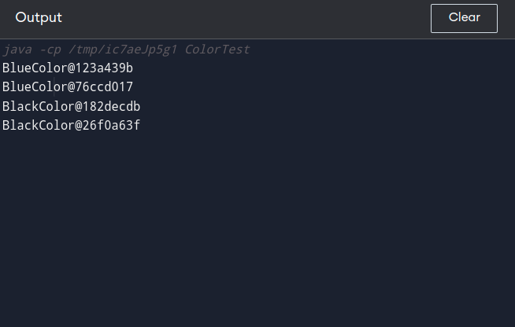

UML Diagram:

